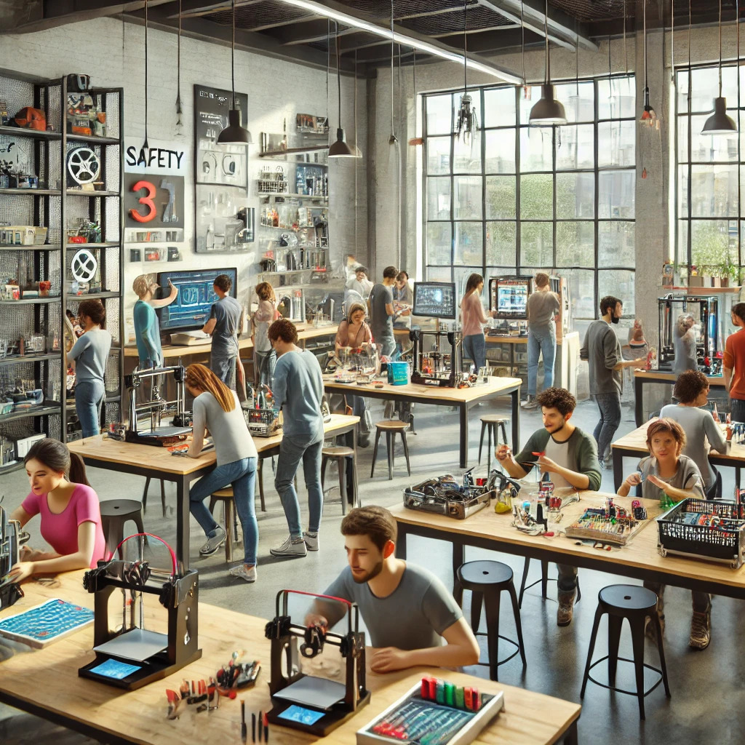
Mission Statement
Crossroads is committed to creating an inclusive space where individuals can explore, innovate, and grow. By providing access to advanced equipment, mentorship, and real-world opportunities, we empower people to pursue their passions and develop new skills. Our mission is to break down barriers to learning, nurture creativity, and inspire the next generation of thinkers, creators, and leaders.

Business Offering
Crossroads brings innovation to the community by establishing an open learning hub focused on STEM education. Crossroads aspires to be more than just a makerspace; it aims to become a hub of inspiration, learning, and innovation in Langford, BC, and beyond. By continuously evolving its offerings and fostering a vibrant, connected community, Crossroads will serve as a blueprint for how inclusive spaces can drive creativity, growth, and resilience.

Problem Statement
Langford, BC, one of Canada's fastest-growing communities, lacks a central space for community members to connect, be inspired, and create together. While the area is home to brilliant universities and colleges that teach essential skills, there are few places where individuals can apply these skills in practical, innovative, and exciting ways. Additionally, as the country faces a mental health and addictions crisis, there’s a critical need for spaces that foster connection, creativity, and purpose.

Solution
Crossroads addresses these challenges by creating a physical space where STEM education is accessible to all, with the only barrier being the willingness to participate. Drawing inspiration from Bruce Alexander's Rat Park experiment, Crossroads recognizes that an enriched, supportive environment can significantly improve well-being and engagement. By providing mentorship, cutting-edge resources, and opportunities for collaboration, Crossroads fosters innovation, combats isolation, and helps build a resilient, forward-thinking community.

The ideal customer persona for Crossroads
Curious Beginners: Individuals with little to no experience but a strong desire to learn how things work, create, and innovate.
Experienced Makers: Professionals or hobbyists who can use the space to work on their own projects while mentoring others.
Students and Educators: Learners looking to supplement formal education with hands-on experiences and educators seeking a space to engage students in practical STEM activities.
Community Builders: Individuals seeking a welcoming, collaborative environment to connect socially and intellectually.

Existing Solutions in the Market
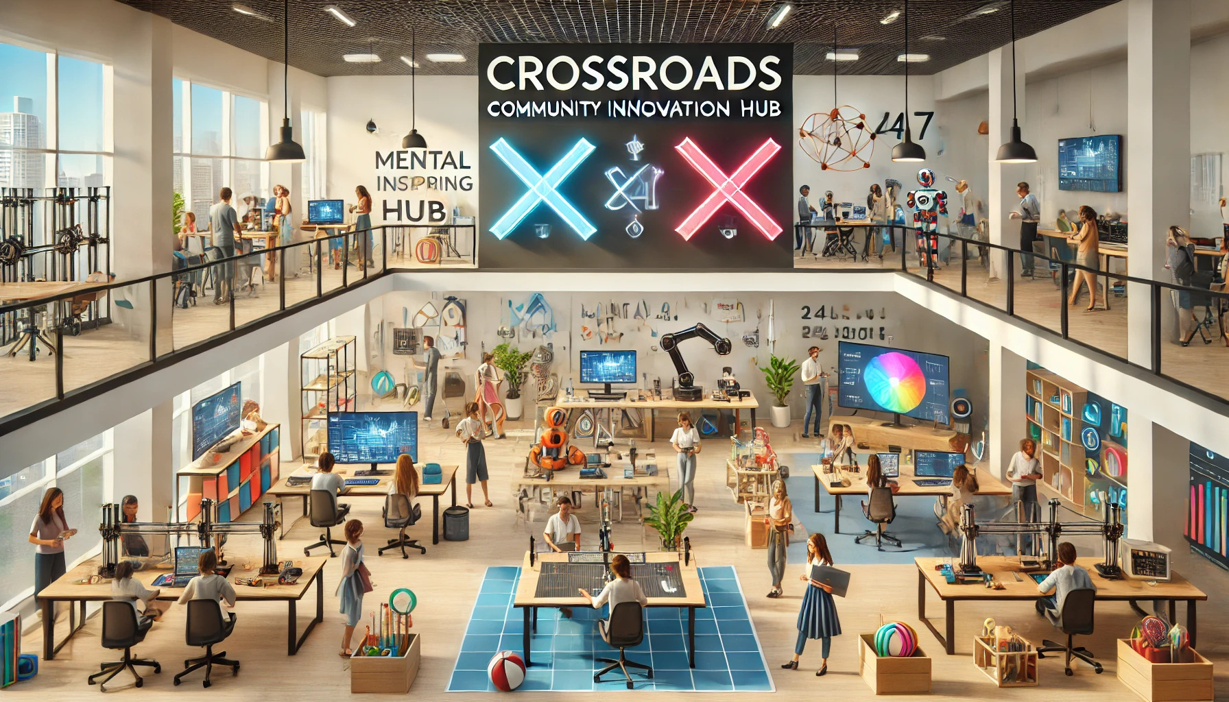
Victoria Makerspace (makerspace.ca) is a key competitor in the region, offering facilities such as a woodshop, cold metal shop, electronics workspace, and a hot metal shed. While it provides valuable resources for creative projects, it has notable limitations. Access is exclusive, requiring users to apply for membership, which creates a barrier for those seeking an open and inclusive environment. Its limited operating hours restrict usage opportunities, and its “club-like” atmosphere caters more to hobbyists and experts, which might discourage beginners or casual participants. Additionally, its resources focus on traditional maker activities and lack a broader emphasis on STEM education or innovation.

Some reviews of Victoria makers space : https://www.reddit.com/r/VictoriaBC/comments/1ekted0/victoria_makerspace/?rdt=47736

UVIC and Camosun college both have a space similar to this which is partly the inspiration for a community learning hub as such.

Opportunity for Crossroads
Crossroads seeks to surpass these limitations by offering a fully drop-in, beginner-friendly community center that welcomes everyone, regardless of experience. Unlike Victoria Makerspace, Crossroads will provide comprehensive STEM-focused resources, including robotics, 3D printing, coding, biology, chemistry, engineering, and more. Operating 24/7, it will provide unmatched flexibility for individuals to innovate and create on their own schedules. With an emphasis on hands-on learning, mentorship, and inclusivity, Crossroads will serve as a true community hub, fostering creativity, connection, and practical skill development. Inspired by the Rat Park experiment, Crossroads will also prioritize mental health and well-being, offering a space that combats isolation and nurtures growth for people of all ages and backgrounds.

Marketing and Promotion
use to reach out to your target customers.
Social Media: Platforms like Facebook, Instagram, and LinkedIn to promote events, share success stories, and engage with the community.
Community Outreach: Flyers, posters, and word-of-mouth campaigns in local schools, libraries, and businesses.
Workshops and Events: Hosting free introductory workshops to showcase what Crossroads offers.
Local Media: Collaborating with newspapers, radio stations, and online blogs to spread awareness.
Partnerships: Teaming up with local schools, universities, and community organizations to promote Crossroads.

Business Model
Start-up Costs: The initial expenses for Crossroads will be substantial. Excluding the costs associated with securing and maintaining the physical space, the cost to launch could range from $500,000 to $5,000,000, depending on the scale of the operation. A detailed cost spreadsheet is being developed to better estimate these expenses.

Revenue Streams:
Corporate Training: Crossroads will partner with local companies and educational institutions to offer corporate training programs in STEM fields, leadership, and innovation. These programs could be structured as team-building exercises or professional development courses.

Event Hosting:
Maker Fairs & Expos: Host annual or bi-annual events where community members, makers, and businesses can showcase their products and ideas. Revenue will be generated through entry fees and booth rentals.

Hackathons & Competitions: Organize paid hackathons, robotics competitions, and creative challenges. These events will attract sponsorships and registration fees while fostering innovation and publicity.

Retail and Merchandising
Maker Shop: A retail section will be established where members can sell their creations, with a small commission going to Crossroads. Additionally, essential materials like 3D printer filaments, electronics kits, and DIY kits will be stocked, attracting walk-in customers and generating revenue.

Merchandising: Branded merchandise (e.g., t-shirts, mugs, or stickers) will be sold to promote the brand and generate extra income.
Corporate Sponsorships: Crossroads will partner with local businesses or large corporations in the tech, engineering, and education sectors. In exchange for financial support or equipment donations, businesses will receive advertising opportunities or be featured in community events.

Grant Funding: Crossroads will explore Canadian government grants and philanthropic funding options targeted at educational initiatives, mental health, and STEM-focused organizations. This funding will help support both start-up and ongoing operational expenses.

Enhancing Community Engagement and Retention

Mentorship and Volunteer Programs
Mentorship Program: Create a structured mentorship program where experienced makers, educators, or professionals volunteer to help beginners. This will add value to the community and encourage more participation.
Student Internships & Volunteer Opportunities: Build partnerships with local universities and colleges, offering internship programs that give students real-world experience in running a community hub, teaching STEM subjects, or learning about new technologies.

Loyalty Rewards: Implement a loyalty program where members earn points for attending workshops, using equipment, or engaging in community events. These points could be redeemed for discounts on membership, workshops, or retail items.

Technology Integration and Automation
Digital Membership Platform
App or Website: Develop a digital platform (app or website) for members to manage their schedules, book equipment, access online resources, and participate in virtual workshops. This platform can also facilitate community interaction through forums, project showcases, and collaboration tools.

Online Courses & Tutorials: To supplement in-person offerings, developing a series of online courses or video tutorials covering basic to advanced topics in STEM. These could be sold as a subscription service or bundled with membership packages.

Data-Driven Insights
Usage Analytics: Track member engagement with equipment, workshops, and events. This data can help identify trends, optimize the scheduling of resources, and personalize offers to specific customer segments. Understanding the most popular equipment or types of workshops will allow Crossroads to better allocate resources and maximize revenue.

Mental Health and Community Impact
Partner with local mental health organizations to provide resources, counseling, or support groups within the space. This will further differentiate Crossroads from traditional makerspaces and position it as a community-focused organization. Workshops or events centered on stress relief, mindfulness, or mental health awareness could also be offered. Collect data on mental health and well-being among members and determine the efficacy of such initiatives in reducing isolation and promoting creativity.

Staff and Volunteers

Safety Instructors:
Crossroads will employ at least two full-time safety instructors to ensure that all equipment is used safely and to prevent accidents. These staff members will be responsible for overseeing the safe operation of machinery and guiding members through proper usage, maintaining a secure and accident-free environment.

Instructors:
Instructors will be hired to teach in a hands-on, engaging way that encourages active participation. Crossroads will assist instructors in creating lesson plans that include physical demonstrations, allowing members to learn concepts through practical experience. Instructors will focus on showing not only the "how" but also the "why" behind each task, ensuring that participants understand the theory behind their actions while maintaining a safe learning environment.

Volunteers:
Volunteers with specific expertise in STEM fields will be crucial in supporting the community. While they will not be expected to formally instruct, their role will involve assisting drop-in members with projects, answering questions, and providing guidance. Volunteers will help create a welcoming atmosphere, especially for newcomers who may feel nervous about using the space for the first time. To further support volunteer engagement, Crossroads will reach out to students with lab or technical expertise to gain valuable volunteer experience while contributing to the community.

List of potential sponsors
Lee valley

General Overview
Mission and Values: What is your mission statement, and how do your values shape your makerspace?

Target Audience: Who do you primarily serve (hobbyists, professionals, students, beginners, etc.)? How do you attract and retain your audience?

Operations and Management
Membership Structure: What membership tiers do you offer, and what benefits are included at each level?

Access: What are your operating hours? Are members provided 24/7 access or limited access?
Safety Protocols: How do you manage safety, especially with high-risk equipment? What training or certifications do you require for members?

Staffing: How many staff and volunteers do you have? What roles do they perform?

Equipment Maintenance: How do you maintain and upgrade equipment? How often is it inspected or replaced?

Facility Features
Space Design: How is your makerspace organized? Are there designated zones for different types of projects (e.g., woodworking, electronics, 3D printing)?

Equipment and Tools: What are your most popular pieces of equipment, and why?

Unique Features: What sets your makerspace apart from others in the region?

Programming and Community Engagement
Workshops and Classes: What types of workshops or events do you host? How do you decide which ones to offer?

Collaboration: How do you encourage collaboration among members? Are there dedicated spaces or systems in place for group projects?

Community Building: What initiatives or programs have been successful in building a strong sense of community?

Volunteer Involvement: How do you recruit, train, and retain volunteers?

Business Model and Financial Sustainability
Revenue Streams: What are your primary sources of revenue (memberships, workshops, retail sales, sponsorships, etc.)?

Startup Costs: What were your biggest expenses when launching the space, and how did you secure funding?

Grants and Sponsors: Do you rely on grants or sponsors? If so, which ones, and how did you approach them?

Challenges and Lessons Learned
Biggest Challenges: What were the biggest challenges you faced when starting your makerspace? How did you overcome them?

Ongoing Issues: What are your current challenges (e.g., funding, maintenance, member retention)?

Lessons for New Makerspaces: What advice would you give to someone opening a new makerspace?

Impact and Growth
Community Impact: How do you measure the impact your space has on the local community?
Member Feedback: How do you gather feedback from members, and how has it influenced your operations?

Future Plans: What are your goals for the future, and how do you plan to grow or innovate?

Technology and Resources
Digital Tools: Do you use any digital tools (e.g., booking systems, online courses, community forums) to enhance the member experience?

STEM Integration: How do you incorporate STEM into your programming, and what has been most successful in attracting interest?

Competitive Landscape
Differentiation: How do you differentiate your makerspace from others in the area?

Collaboration vs. Competition: Do you collaborate with other makerspaces or see them as competitors?

Mental Health and Accessibility
Accessibility: What steps have you taken to make your space inclusive and accessible for people of all abilities?

Well-Being: Do you offer any programs or initiatives to address mental health or community well-being?

Closing Questions
Best Feature: If you had to pick one feature of your makerspace that you’re most proud of, what would it be and why?

Room for Improvement: If you could change one thing about your makerspace, what would it be?

Visiting Crossroads: Would you be open to visiting Crossroads once it’s up and running to share advice or collaborate?
Subject: Seeking Guidance and Support to Launch Crossroads: A Community STEM Learning Hub

Dear [],

My name is Cameron Kibble, and I am passionately pursuing the creation of Crossroads, a community learning hub focused on making STEM education accessible, inclusive, and impactful in Langford, BC. Inspired by the need for a space that fosters innovation, creativity, and mental well-being, Crossroads aims to empower individuals of all ages and backgrounds to develop skills, connect with others, and explore new ideas.

To turn this vision into reality, I am seeking guidance, mentorship, and support from experienced professionals who share a commitment to education, innovation, and community development. I would greatly appreciate assistance in the following areas:

- Legal and Operational Guidance:
  - Ensuring compliance with local regulations.
  - Navigating zoning and business permit requirements.
  - Establishing organizational bylaws and governance structures.
- Financial Planning and Support:
  - Creating a detailed business plan and financial model.
  - Exploring grants, loans, and other funding opportunities.
  - Identifying potential investors and sponsors who share this vision.
- Commercial Space Acquisition:
  - Locating an ideal space that meets the needs of a 24/7 community learning hub.
  - Understanding commercial leasing or purchasing processes.
- Community and Professional Engagement:
  - Attracting like-minded individuals to join this project as mentors, instructors, or volunteers.
  - Building partnerships with local schools, universities, and businesses.
  - Gaining insights from professionals who have launched similar initiatives.

How You Can Help
If you have expertise in any of these areas or are interested in contributing to Crossroads, I would love to hear from you. Your guidance could play a pivotal role in making this hub a cornerstone of Langford’s community, fostering learning and innovation for generations to come.

Next Steps
Please feel free to reach out to me directly at Cameron.kibble@icloud.com or 250-888-7236. I am eager to meet with anyone who has ideas, resources, or insights to share. Together, we can create a space that inspires curiosity, combats isolation, and builds a resilient, forward-thinking community.

Thank you for your time and consideration. I look forward to connecting with you.

Sincerely,
Cameron Kibble
250-888-7236
cameron.kibble@icloud.com

